activity_main.xml:

<?xml version="1.0" encoding="utf-8"?>
<LinearLayout xmlns:android="http://schemas.android.com/apk/res/android"
android:orientation="vertical"
android:layout_width="match_parent"
android:layout_height="match_parent">
<TextView android:id="@+id/textView" android:layout_width="match_parent"
android:layout_height="wrap_content"
android:layout_margin="30dp"
android:gravity="center"
android:text="Text To Test"
android:textSize="25sp"
android:textStyle="bold" />
<Button
android:id="@+id/button"
android:layout_width="match_parent"
android:layout_height="wrap_content"
android:layout_margin="20dp"
android:gravity="center"
android:text="Change font size"
android:textSize="25sp" />
<Button
android:id="@+id/button1"
android:layout_width="match_parent"
android:layout_height="wrap_content"
android:layout_margin="20dp"
android:gravity="center"
android:text="Change color"
android:textSize="25sp" />
<TextView android:id="@+id/textView1"
android:layout_width="match_parent"
android:layout_height="wrap_content"
android:gravity="center"
android:text="Name: Vinod Kumar L"
android:textSize="25sp" />

<TextView
android:id="@+id/textView2"
android:layout_width="match_parent"
android:layout_height="wrap_content"
android:gravity="center"
android:text="RegNo: 950019104050"
android:textSize="25sp" />
</LinearLayout>

MainActivity.java:
package com.font.color;

import android.graphics.Color;
import android.os.Bundle;
import android.view.View;
import android.widget.Button;
import android.widget.TextView;
import androidx.appcompat.app.AppCompatActivity;
public class MainActivity extends AppCompatActivity
{
int ch=1;
float font=30;
@Override
protected void onCreate(Bundle savedInstanceState)
{
super.onCreate(savedInstanceState);
setContentView(R.layout.activity_main);
final TextView t= (TextView) findViewById(R.id.textView);
Button b1= (Button) findViewById(R.id.button);
b1.setOnClickListener(new View.OnClickListener() {
@Override
public void onClick(View v) {
t.setTextSize(font);
font = font + 5;
if (font == 50)
font = 30;
}
});
Button b2= (Button) findViewById(R.id.button1);
b2.setOnClickListener(new View.OnClickListener() {
@Override
public void onClick(View v) {
switch (ch) {
case 1:
t.setTextColor(Color.RED);
break;
case 2:
t.setTextColor(Color.GREEN);
break;
case 3:
t.setTextColor(Color.BLUE);
break;
case 4:
t.setTextColor(Color.CYAN);
break;
case 5:
t.setTextColor(Color.YELLOW);
break;
case 6:
t.setTextColor(Color.MAGENTA);
break;
}
ch++;
if (ch == 7)
ch = 1;
}
});
}
}

Output:
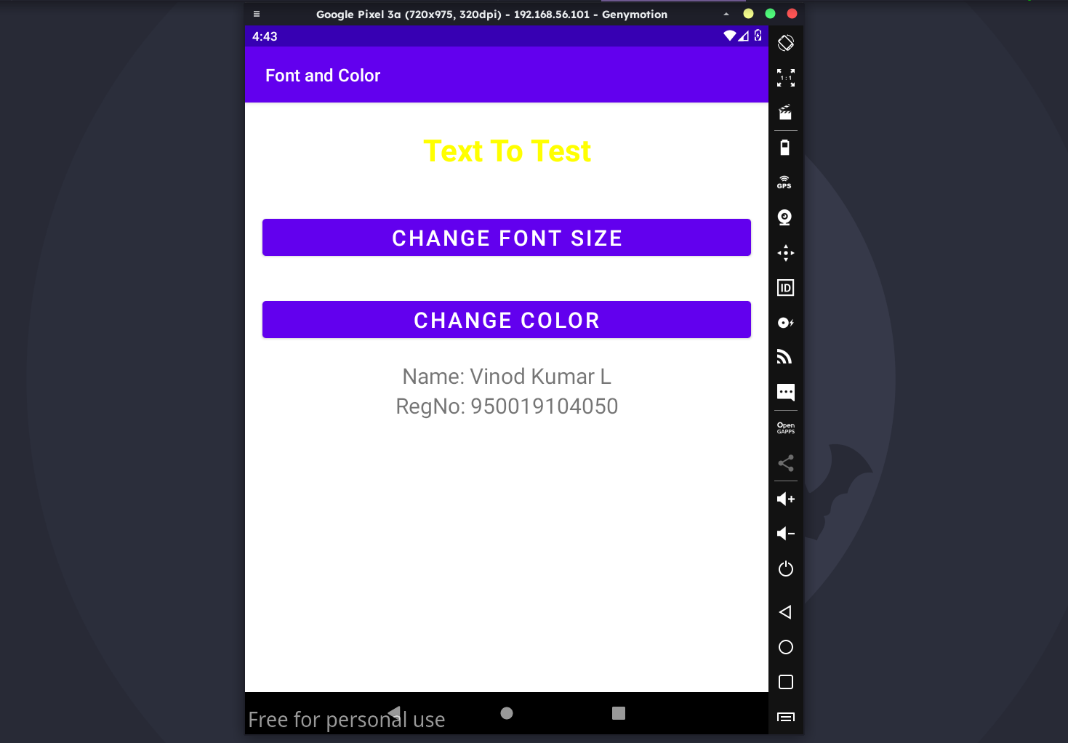

activity_main.xml:
<?xml version="1.0" encoding="utf-8"?>
<RelativeLayout xmlns:android="http://schemas.android.com/apk/res/android"
xmlns:tools="http://schemas.android.com/tools"
android:layout_width="match_parent"
android:layout_height="match_parent"
tools:context=".MainActivity">
<LinearLayout
android:layout_width="match_parent"
android:layout_height="100dp">
<TextView
android:id="@+id/textView"
android:layout_width="match_parent"
android:layout_height="wrap_content"
android:layout_margin="30dp"
android:text="Details Form"
android:textSize="25sp"
android:gravity="center"/>
</LinearLayout>
<GridLayout
android:id="@+id/gridLayout"
android:layout_width="match_parent"
android:layout_height="match_parent"
android:layout_marginTop="100dp"
android:layout_marginBottom="200dp"
android:columnCount="2"
android:rowCount="3">
<TextView
android:id="@+id/textView1"
android:layout_width="wrap_content"
android:layout_height="wrap_content"
android:layout_row="0"
android:layout_column="0"
android:layout_margin="10dp"
android:gravity="center"
android:text="Name"
android:textSize="20sp" />
<EditText
android:id="@+id/editText"
android:layout_width="wrap_content"
android:layout_height="wrap_content"
android:layout_row="0"
android:layout_column="1"
android:layout_margin="10dp"
android:ems="10" />
<TextView
android:id="@+id/textView2"
android:layout_width="wrap_content"
android:layout_height="wrap_content"
android:layout_row="1"
android:layout_column="0"
android:layout_margin="10dp"
android:gravity="center"
android:text="Reg.No"
android:textSize="20sp" />
<EditText
android:id="@+id/editText2"
android:layout_width="wrap_content"
android:layout_height="wrap_content"
android:layout_row="1"
android:layout_column="1"
android:layout_margin="10dp"
android:ems="10"
android:inputType="number" />
<TextView
android:id="@+id/textView3"
android:layout_width="wrap_content"
android:layout_height="wrap_content"
android:layout_row="2"
android:layout_column="0"
android:layout_margin="10dp"
android:gravity="center"
android:text="Dept"
android:textSize="20sp" />
<Spinner
android:id="@+id/spinner"
android:layout_width="wrap_content"
android:layout_height="wrap_content"
android:layout_row="2"
android:layout_column="1"
android:layout_margin="10dp"
android:spinnerMode="dropdown" />
</GridLayout>
<Button
android:id="@+id/button"
android:layout_width="wrap_content"
android:layout_height="wrap_content"
android:layout_alignParentBottom="true"
android:layout_centerInParent="true"
android:layout_marginBottom="150dp"
android:text="Submit"/>
<TextView android:id="@+id/textView11"
android:layout_width="match_parent"
android:layout_height="wrap_content"
android:gravity="center"
android:layout_marginTop="600dp"
android:text="Name: Vinod Kumar L"
android:textSize="25sp" />

<TextView
android:id="@+id/textView12"
android:layout_width="match_parent"
android:layout_height="wrap_content"
android:gravity="center"
android:text="RegNo: 950019104050"
android:layout_marginTop="650dp"
android:textSize="25sp" />
</RelativeLayout>

activity_second.xml:
<?xml version="1.0" encoding="utf-8"?>
<LinearLayout xmlns:android="http://schemas.android.com/apk/res/android"
xmlns:tools="http://schemas.android.com/tools"
android:layout_width="match_parent"
android:layout_height="match_parent"

tools:context="com.layoutmanager.listener.SecondActivity"
android:orientation="vertical"
android:gravity="center">
<TextView
android:id="@+id/textView1"
android:layout_width="wrap_content"
android:layout_height="wrap_content"
android:layout_margin="20dp"
android:text="New Text"
android:textSize="30sp"/>
<TextView
android:id="@+id/textView2"
android:layout_width="wrap_content"
android:layout_height="wrap_content"
android:layout_margin="20dp"
android:text="New Text"
android:textSize="30sp"/>
<TextView
android:id="@+id/textView3"
android:layout_width="wrap_content"
android:layout_height="wrap_content"
android:layout_margin="20dp"
android:text="New Text"
android:textSize="30sp"/>
</LinearLayout>

MainActivity.java:
package com.layoutmanager.listener;

import android.content.Intent;
import android.os.Bundle;
import android.view.View;
import android.widget.ArrayAdapter;
import android.widget.Button;
import android.widget.EditText;
import android.widget.Spinner;
import androidx.appcompat.app.AppCompatActivity;
public class MainActivity extends AppCompatActivity {
//Defining the Views
EditText e1,e2;
Button bt;
Spinner s;
//Data for populating in Spinner
String [] dept_array={"CSE","ECE","IT","Mech","Civil"};
String name,reg,dept;
@Override
protected void onCreate(Bundle savedInstanceState) {
super.onCreate(savedInstanceState);
setContentView(R.layout.activity_main);
//Referring the Views
e1= (EditText) findViewById(R.id.editText);
e2= (EditText) findViewById(R.id.editText2);
bt= (Button) findViewById(R.id.button);
s= (Spinner) findViewById(R.id.spinner);
//Creating Adapter for Spinner for adapting the data from array to Spinner
ArrayAdapter adapter= new
ArrayAdapter(MainActivity.this,android.R.layout.simple_spinner_item,dept_array);
s.setAdapter(adapter);
//Creating Listener for Button
bt.setOnClickListener(new View.OnClickListener() {
@Override
public void onClick(View v) {
//Getting the Values from Views(Edittext & Spinner)
name=e1.getText().toString();
reg=e2.getText().toString();
dept=s.getSelectedItem().toString();
//Intent For Navigating to Second Activity
Intent i = new Intent(MainActivity.this,SecondActivity.class);
//For Passing the Values to Second Activity
i.putExtra("name_key", name);
i.putExtra("reg_key",reg);
i.putExtra("dept_key", dept);
startActivity(i);
}
});
}}

SecondActivity.java:
package com.layoutmanager.listener;

import androidx.appcompat.app.AppCompatActivity;
import android.content.Intent;
import android.os.Bundle;
import android.widget.TextView;
public class SecondActivity extends AppCompatActivity {
TextView t1,t2,t3;
String name,reg,dept;
@Override
protected void onCreate(Bundle savedInstanceState) {
super.onCreate(savedInstanceState);
setContentView(R.layout.activity_second);
t1= (TextView) findViewById(R.id.textView1);
t2= (TextView) findViewById(R.id.textView2);
t3= (TextView) findViewById(R.id.textView3);
//Getting the Intent
Intent i = getIntent();
//Getting the Values from First Activity using the Intent received
name=i.getStringExtra("name_key");
reg=i.getStringExtra("reg_key");
dept=i.getStringExtra("dept_key");
//Setting the Values to Intent
t1.setText(name);
t2.setText(reg);
t3.setText(dept);
}
}

Output:
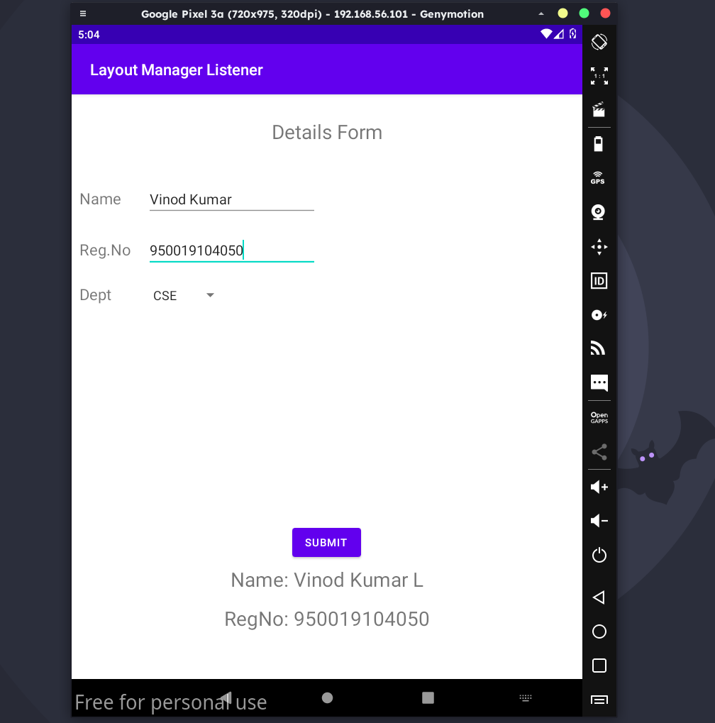

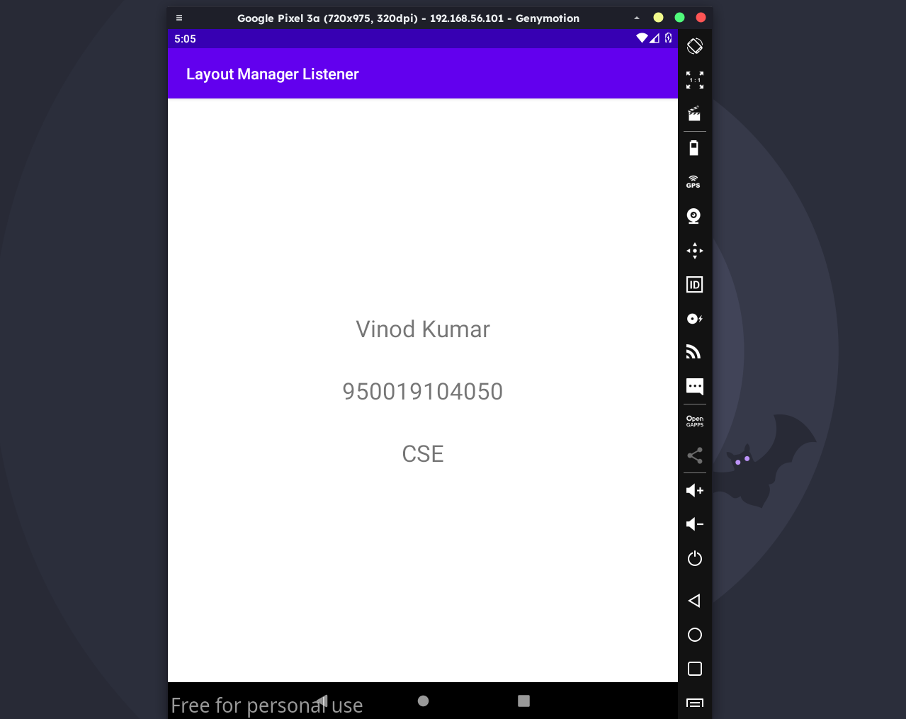

activity_main.xml:

<?xml version="1.0" encoding="utf-8"?>
<RelativeLayout xmlns:android="http://schemas.android.com/apk/res/android"
android:layout_width="match_parent"
android:layout_height="match_parent">
<ImageView
android:layout_width="match_parent"
android:layout_height="match_parent"
android:id="@+id/imageView" />
</RelativeLayout>

MainActivity.java:
package draw.basic.graphical.primitives;

import android.app.Activity;
import android.graphics.Bitmap;
import android.graphics.Canvas;
import android.graphics.Color;
import android.graphics.Paint;
import android.graphics.drawable.BitmapDrawable;
import android.os.Bundle;
import android.widget.ImageView;
public class MainActivity extends Activity {
@Override
public void onCreate(Bundle savedInstanceState) {
super.onCreate(savedInstanceState);
setContentView(R.layout.activity_main);
//Creating a Bitmap
Bitmap bg = Bitmap.createBitmap(720, 1280, Bitmap.Config.ARGB_8888);
//Setting the Bitmap as background for the ImageView
ImageView i = (ImageView) findViewById(R.id.imageView);
i.setBackgroundDrawable(new BitmapDrawable(bg));
//Creating the Canvas Object
Canvas canvas = new Canvas(bg);
//Creating the Paint Object and set its color & TextSize
Paint paint = new Paint();
paint.setColor(Color.BLUE);
paint.setTextSize(50);
//To draw a Rectangle
canvas.drawText("Rectangle", 420, 150, paint);
canvas.drawRect(400, 200, 650, 700, paint);
//To draw a Circle
canvas.drawText("Circle", 120, 150, paint);
canvas.drawCircle(200, 350, 150, paint);
//To draw a Square
canvas.drawText("Square", 120, 800, paint);
canvas.drawRect(50, 850, 350, 1150, paint);
//To draw a Line
canvas.drawText("Line", 480, 800, paint);
canvas.drawLine(520, 850, 520, 1150, paint);
}
}

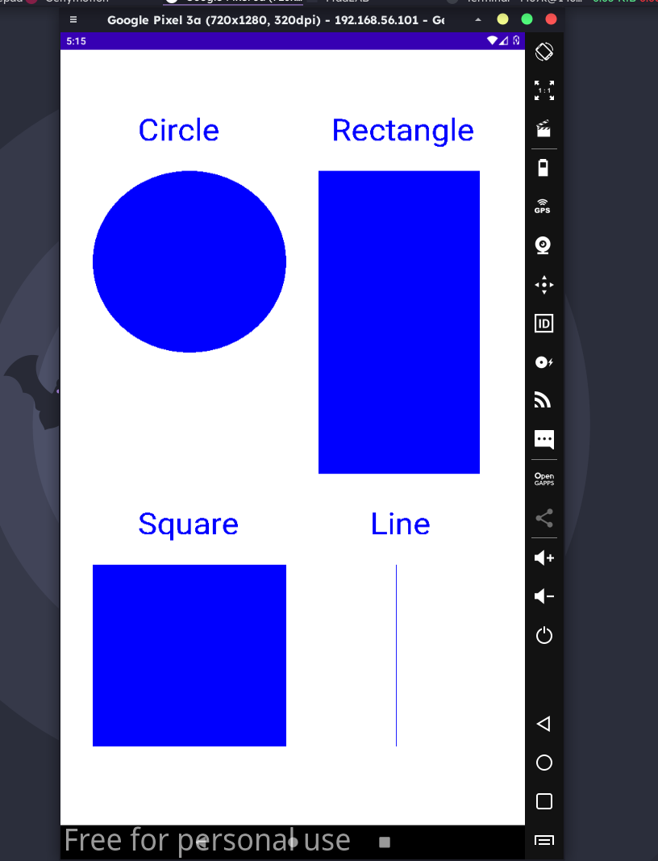

activity_main.xml:

<?xml version="1.0" encoding="utf-8"?>
<AbsoluteLayout xmlns:android="http://schemas.android.com/apk/res/android"
android:layout_width="match_parent"
android:layout_height="match_parent">
<TextView
android:layout_width="wrap_content"
android:layout_height="wrap_content"
android:layout_x="50dp"
android:layout_y="20dp"
android:text="Student Details"
android:textSize="30sp" />
<TextView
android:layout_width="wrap_content"
android:layout_height="wrap_content"
android:layout_x="20dp"
android:layout_y="110dp"
android:text="Enter Rollno:"
android:textSize="20sp" />
<EditText
android:id="@+id/Rollno"
android:layout_width="150dp"
android:layout_height="wrap_content"
android:layout_x="175dp"
android:layout_y="100dp"
android:inputType="number"
android:textSize="20sp" />
<TextView
android:layout_width="wrap_content"
android:layout_height="wrap_content"
android:layout_x="20dp"
android:layout_y="160dp"
android:text="Enter Name:"
android:textSize="20sp" />
<EditText
android:id="@+id/Name"
android:layout_width="150dp"
android:layout_height="wrap_content"
android:layout_x="175dp"
android:layout_y="150dp"
android:inputType="text"
android:textSize="20sp" />
<TextView
android:layout_width="wrap_content"
android:layout_height="wrap_content"
android:layout_x="20dp"
android:layout_y="210dp"
android:text="Enter Marks:"
android:textSize="20sp" />
<EditText
android:id="@+id/Marks"
android:layout_width="150dp"
android:layout_height="wrap_content"
android:layout_x="175dp"
android:layout_y="200dp"
android:inputType="number"
android:textSize="20sp" />
<Button
android:id="@+id/Insert"
android:layout_width="150dp"
android:layout_height="wrap_content"
android:layout_x="25dp"
android:layout_y="300dp"
android:text="Insert"
android:textSize="30dp" />
<Button
android:id="@+id/Delete"
android:layout_width="150dp"
android:layout_height="wrap_content"
android:layout_x="200dp"
android:layout_y="300dp"
android:text="Delete"
android:textSize="30dp" />
<Button
android:id="@+id/Update"
android:layout_width="150dp"
android:layout_height="wrap_content"
android:layout_x="25dp"
android:layout_y="400dp"
android:text="Update"
android:textSize="30dp" />
<Button
android:id="@+id/View"
android:layout_width="150dp"
android:layout_height="wrap_content"
android:layout_x="200dp"
android:layout_y="400dp"
android:text="View"
android:textSize="30dp" />
<Button
android:id="@+id/ViewAll"
android:layout_width="200dp"
android:layout_height="wrap_content"
android:layout_x="100dp"
android:layout_y="500dp"
android:text="View All"
android:textSize="30dp" />
</AbsoluteLayout>

MainActivity.java:
package make.use.of.db;

import android.app.Activity;
import android.app.AlertDialog.Builder;
import android.content.Context;
import android.database.Cursor;
import android.database.sqlite.SQLiteDatabase;
import android.os.Bundle;
import android.view.View;
import android.view.View.OnClickListener;
import android.widget.Button;
import android.widget.EditText;
public class MainActivity extends Activity implements OnClickListener
{
EditText Rollno,Name,Marks;
Button Insert,Delete,Update,View,ViewAll;
SQLiteDatabase db;
/** Called when the activity is first created. */
@Override
public void onCreate(Bundle savedInstanceState)
{
super.onCreate(savedInstanceState);
setContentView(R.layout.activity_main);
Rollno=(EditText)findViewById(R.id.Rollno);
Name=(EditText)findViewById(R.id.Name);
Marks=(EditText)findViewById(R.id.Marks);
Insert=(Button)findViewById(R.id.Insert);
Delete=(Button)findViewById(R.id.Delete);
Update=(Button)findViewById(R.id.Update);
View=(Button)findViewById(R.id.View);
ViewAll=(Button)findViewById(R.id.ViewAll);
Insert.setOnClickListener(this);
Delete.setOnClickListener(this);
Update.setOnClickListener(this);
View.setOnClickListener(this);
ViewAll.setOnClickListener(this);
// Creating database and table
db=openOrCreateDatabase("StudentDB", Context.MODE_PRIVATE, null);
db.execSQL("CREATE TABLE IF NOT EXISTS student(rollno VARCHAR,name VARCHAR,marks VARCHAR);");
}
public void onClick(View view)
{
// Inserting a record to the Student table
if(view==Insert)
{
// Checking for empty fields
if(Rollno.getText().toString().trim().length()==0||
Name.getText().toString().trim().length()==0||
Marks.getText().toString().trim().length()==0)
{
showMessage("Error", "Please enter all values");
return;
}
db.execSQL("INSERT INTO student VALUES('"+Rollno.getText()+"','"+Name.getText()+
"','"+Marks.getText()+"');");
showMessage("Success", "Record added");
clearText();
}
// Deleting a record from the Student table
if(view==Delete)
{
// Checking for empty roll number
if(Rollno.getText().toString().trim().length()==0)
{
showMessage("Error", "Please enter Rollno");
return;
}
Cursor c=db.rawQuery("SELECT * FROM student WHERE rollno='"+Rollno.getText()+"'", null);
if(c.moveToFirst())
{
db.execSQL("DELETE FROM student WHERE rollno='"+Rollno.getText()+"'");
showMessage("Success", "Record Deleted");
}
else
{
showMessage("Error", "Invalid Rollno");
}
clearText();
}
// Updating a record in the Student table
if(view==Update)
{
// Checking for empty roll number
if(Rollno.getText().toString().trim().length()==0)
{
showMessage("Error", "Please enter Rollno");
return;
}
Cursor c=db.rawQuery("SELECT * FROM student WHERE rollno='"+Rollno.getText()+"'", null);
if(c.moveToFirst()) {
db.execSQL("UPDATE student SET name='" + Name.getText() + "',marks='" +
Marks.getText() +
"' WHERE rollno='"+Rollno.getText()+"'");
showMessage("Success", "Record Modified");
}
else {
showMessage("Error", "Invalid Rollno");
}
clearText();
}
// Display a record from the Student table
if(view==View)
{
// Checking for empty roll number
if(Rollno.getText().toString().trim().length()==0)
{
showMessage("Error", "Please enter Rollno");
return;
}
Cursor c=db.rawQuery("SELECT * FROM student WHERE rollno='"+Rollno.getText()+"'", null);
if(c.moveToFirst())
{
Name.setText(c.getString(1));
Marks.setText(c.getString(2));
}
else
{
showMessage("Error", "Invalid Rollno");
clearText();
}
}
// Displaying all the records
if(view==ViewAll)
{
Cursor c=db.rawQuery("SELECT * FROM student", null);
if(c.getCount()==0)
{
showMessage("Error", "No records found");
return;
}
StringBuffer buffer=new StringBuffer();
while(c.moveToNext())
{
buffer.append("Rollno: "+c.getString(0)+"\n");
buffer.append("Name: "+c.getString(1)+"\n");
buffer.append("Marks: "+c.getString(2)+"\n\n");
}
showMessage("Student Details", buffer.toString());
}
}
public void showMessage(String title,String message)
{
Builder builder=new Builder(this);
builder.setCancelable(true);
builder.setTitle(title);
builder.setMessage(message);
builder.show();
}
public void clearText()
{
Rollno.setText("");
Name.setText("");
Marks.setText("");
Rollno.requestFocus();
}
}

Output:

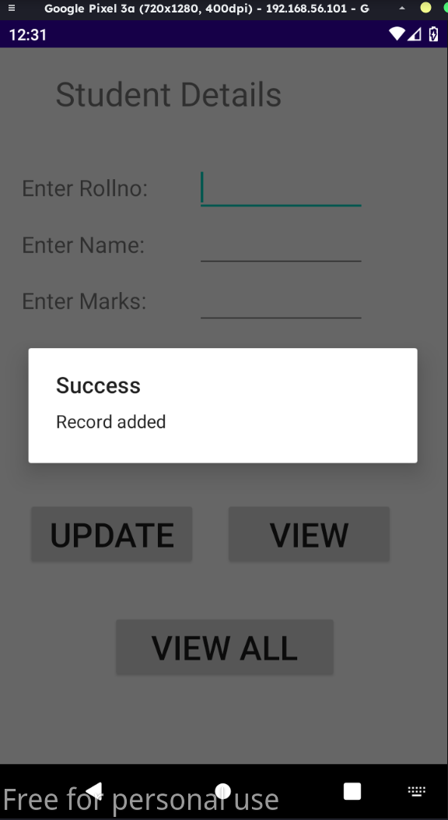
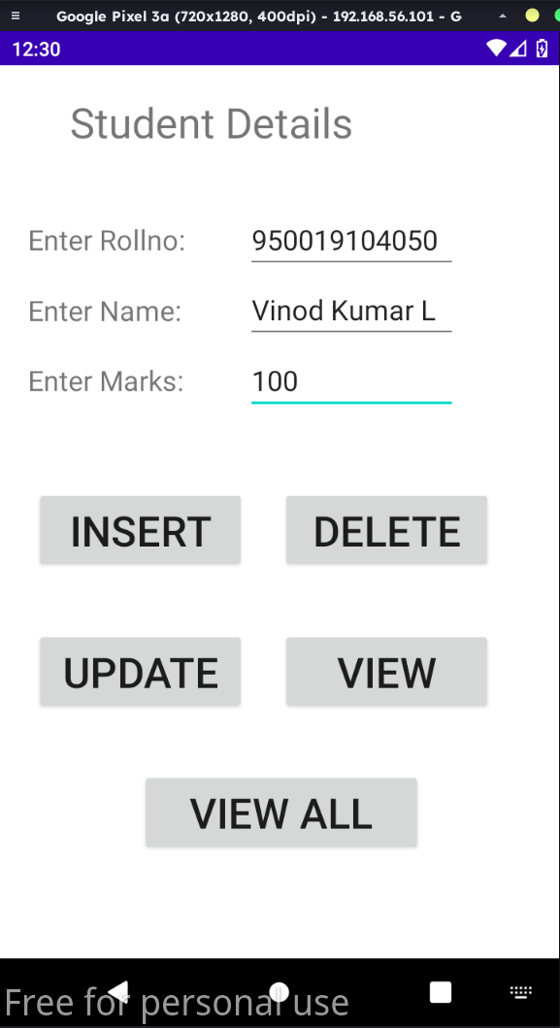

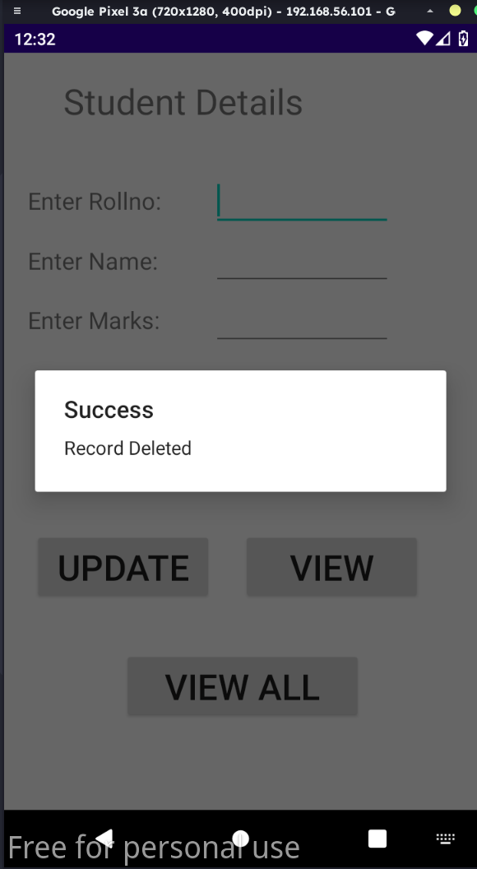
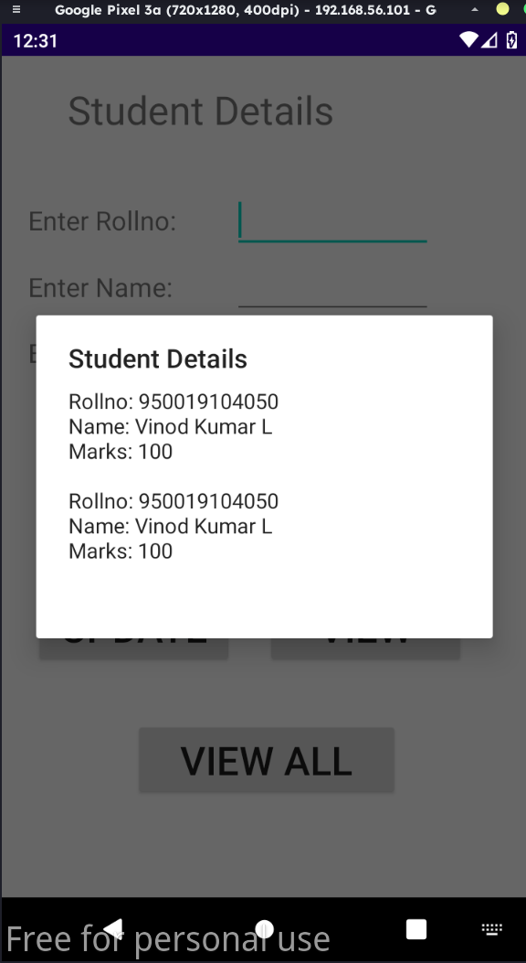

activity_main.xml:

<?xml version="1.0" encoding="utf-8"?>
<LinearLayout xmlns:android="http://schemas.android.com/apk/res/android"
xmlns:app="http://schemas.android.com/apk/res-auto"
xmlns:tools="http://schemas.android.com/tools"
android:layout_width="match_parent"
android:layout_height="match_parent"
android:orientation="vertical"
android:gravity="center"
tools:context=".MainActivity">
<Button
android:id="@+id/btnSimpleNotification"
android:layout_width="wrap_content"
android:layout_height="wrap_content"
android:text="Simple Notification" />
<Button
android:id="@+id/btnNotificationIcon"
android:layout_width="wrap_content"
android:layout_height="wrap_content"
android:text="Notification With Icon" />
<Button
android:id="@+id/btnNotificationImage"
android:layout_width="wrap_content"
android:layout_height="wrap_content"
android:text="Notification With Image" />

<Button
android:id="@+id/btnNotificationWithGroupConvo"
android:layout_width="wrap_content"
android:layout_height="wrap_content"
android:text="Notification With Group Conversation" />
<Button
android:id="@+id/btnNotificationSemantic"
android:layout_width="wrap_content"
android:layout_height="wrap_content"
android:text="Notification Semantic Action" />
<TextView android:id="@+id/textView11"
android:layout_width="match_parent"
android:layout_height="wrap_content"
android:gravity="center"
android:text="Name: Vinod Kumar L"
android:textSize="25sp" />

<TextView
android:id="@+id/textView12"
android:layout_width="match_parent"
android:layout_height="wrap_content"
android:gravity="center"
android:text="RegNo: 950019104050"
android:textSize="25sp" />
</LinearLayout>

MainActivity.java:

package make.use.of.notification.manager;

import android.app.NotificationChannel;
import android.app.NotificationManager;
import android.app.PendingIntent;
import android.content.Context;
import android.content.Intent;
import android.net.Uri;
import androidx.core.app.NotificationCompat;
import androidx.appcompat.app.AppCompatActivity;
import androidx.core.app.Person;
import androidx.core.graphics.drawable.IconCompat;
import android.os.Build;
import android.os.Bundle;
import android.view.View;
import android.widget.Button;
import android.widget.Toast;
import java.util.Date;
public class MainActivity extends AppCompatActivity implements View.OnClickListener {
NotificationManager notificationManager;
NotificationCompat.Builder builder;
NotificationChannel channel;
CharSequence charSequence = "";
@Override
protected void onCreate(Bundle savedInstanceState) {
super.onCreate(savedInstanceState);
setContentView(R.layout.activity_main);
Button btnSimpleNotification = findViewById(R.id.btnSimpleNotification);
Button btnNotificationIcon = findViewById(R.id.btnNotificationIcon);
Button btnNotificationImage = findViewById(R.id.btnNotificationImage);
Button btnNotificationWithGroupConvo = findViewById(R.id.btnNotificationWithGroupConvo);
Button btnNotificationSemantic = findViewById(R.id.btnNotificationSemantic);
charSequence = btnNotificationIcon.getText();
btnSimpleNotification.setOnClickListener(this);
btnNotificationIcon.setOnClickListener(this);
btnNotificationImage.setOnClickListener(this);
btnNotificationWithGroupConvo.setOnClickListener(this);
btnNotificationSemantic.setOnClickListener(this);
notificationManager = (NotificationManager) getSystemService(Context.NOTIFICATION_SERVICE);
CharSequence name = "My Notification";
String description = "yadda yadda";
int importance = NotificationManager.IMPORTANCE_DEFAULT;
if (Build.VERSION.SDK_INT >= Build.VERSION_CODES.O) {
channel = new NotificationChannel("1", name, importance);
}
if (Build.VERSION.SDK_INT >= Build.VERSION_CODES.O) {
channel.setDescription(description);
}
if (Build.VERSION.SDK_INT >= Build.VERSION_CODES.O) {
builder = new NotificationCompat.Builder(MainActivity.this, channel.getId())
.setSmallIcon(R.mipmap.ic_launcher);
}
if (Build.VERSION.SDK_INT >= Build.VERSION_CODES.O) {
notificationManager.createNotificationChannel(channel);
}
}
@Override
public void onClick(View v) {
switch (v.getId()) {
case R.id.btnSimpleNotification:
simpleNotification();
break;
case R.id.btnNotificationIcon:
notificationWithIcon();
break;
case R.id.btnNotificationImage:
notificationWithImage();
break;
case R.id.btnNotificationWithGroupConvo:
notificationWithGroupConvo();
break;
case R.id.btnNotificationSemantic:
notificationSemantic();
break;
}
}
private void simpleNotification() {
Person jd = new Person.Builder().setName("Vinod Kumar") .setImportant(true) .build();
new NotificationCompat.MessagingStyle(jd)
.addMessage("Check your mail", new Date().getTime(), jd) .setBuilder(builder);
notificationManager.notify(1, builder.build());
}
private void notificationWithIcon() {
Person anupam = new Person.Builder()
.setName("Vinod")
.setIcon(IconCompat.createWithResource(this, R.drawable.ic_launcher_foreground))
.setImportant(true) .build();
new NotificationCompat.MessagingStyle(anupam)
.addMessage("Check your calender!", new Date().getTime(), anupam)
.setBuilder(builder);
notificationManager.notify(2, builder.build());
}
private void notificationWithImage() {
Person bot = new Person.Builder()
.setName("Bot") .setImportant(true)
.setBot(true) .build();
Uri uri = Uri.parse("android.resource://com.journaldev.androidpnotifications/drawable/"+R.drawable.ic_launcher_foreground);
NotificationCompat.MessagingStyle.Message message = new
NotificationCompat.MessagingStyle.Message("Check your calender!", new Date().getTime(), bot);
message.setData("image/*",uri);
new NotificationCompat.MessagingStyle(bot)
.addMessage(message) .setGroupConversation(true).setBuilder(builder);
notificationManager.notify(3, builder.build());
}
private void notificationWithGroupConvo()
{
Person jd = new Person.Builder()
.setName("Vinod Kumar") .build();
Person anupam = new Person.Builder()
.setName("Vinod")
.setIcon(IconCompat.createWithResource(this, R.drawable.ic_launcher_foreground))
.setImportant(true).build();
Person bot = new Person.Builder()
.setName("Bot").setBot(true) .build();
Uri uri = Uri.parse("android.resource://com.journaldev.androidpnotifications/drawable/"+R.drawable.ic_launcher_foreground);
NotificationCompat.MessagingStyle.Message message = new
NotificationCompat.MessagingStyle.Message("", new Date().getTime(), bot);
message.setData("image/*",uri);
new NotificationCompat.MessagingStyle(bot)
.addMessage("Hi. How are you?", new Date().getTime(), anupam)
.addMessage(message)
.addMessage("Does this image look good?", new Date().getTime(), bot)
.addMessage("Looks good!", new Date().getTime(), jd)
.setGroupConversation(true)
.setConversationTitle("Sample Conversation")
.setBuilder(builder);
notificationManager.notify(4, builder.build());
}
private void notificationSemantic()
{
Person jd = new Person.Builder()
.setName("Vinod Kumar")
.build();
Person anupam = new Person.Builder()
.setName("Vinod")
.setIcon(IconCompat.createWithResource(this, R.drawable.ic_launcher_foreground))
.setImportant(true)
.build();
Person bot = new Person.Builder()
.setName("Bot")
.setBot(true)
.build();
Uri uri = Uri.parse("android.resource://com.journaldev.androidpnotifications/drawable/"+R.drawable.ic_launcher_foreground);
Intent intent = new Intent(this, MainActivity.class);
intent.putExtra("hi","Notifications were read");
PendingIntent pendingIntent = PendingIntent.getActivity(this, 0, intent, 0);
NotificationCompat.MessagingStyle.Message message = new
NotificationCompat.MessagingStyle.Message("", new Date().getTime(), bot);
message.setData("image/*",uri);
NotificationCompat.Action replyAction =
new NotificationCompat.Action.Builder(
R.drawable.ic_launcher_foreground, "MARK READ", pendingIntent)
.setSemanticAction(NotificationCompat.Action.SEMANTIC_ACTION_MARK_AS_READ)
.build();
NotificationCompat.Builder separateBuilder = builder;
separateBuilder.addAction(replyAction);
new NotificationCompat.MessagingStyle(bot)
.addMessage("Hi. How are you?", new Date().getTime(), anupam)
.addMessage(message)
.addMessage("Does this image look good?", new Date().getTime(), bot)
.addMessage("Looks good!", new Date().getTime(), jd)
.setGroupConversation(true)
.setConversationTitle("Sample Conversation")
.setBuilder(separateBuilder);
notificationManager.notify(5, separateBuilder.build());
}
@Override
protected void onResume() {
super.onResume();
if(getIntent()!=null && getIntent().getExtras()!=null)
{
String value = getIntent().getStringExtra("hi");
Toast.makeText(getApplicationContext(),value,Toast.LENGTH_LONG).show();
}
}
}

Output:

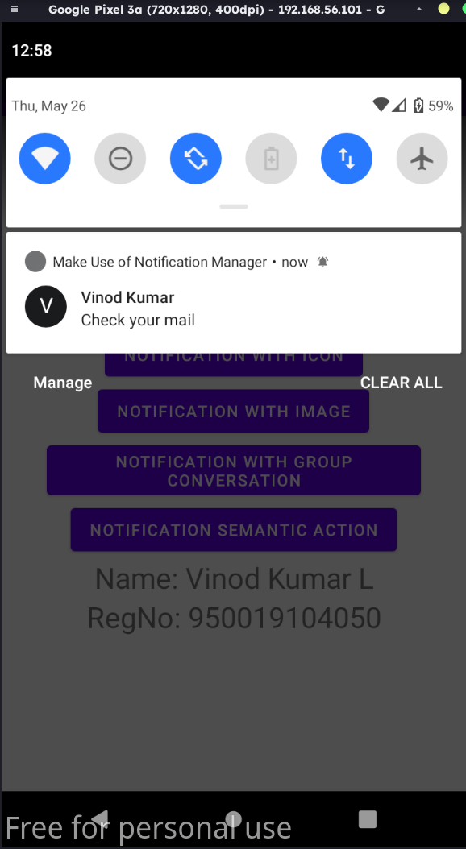
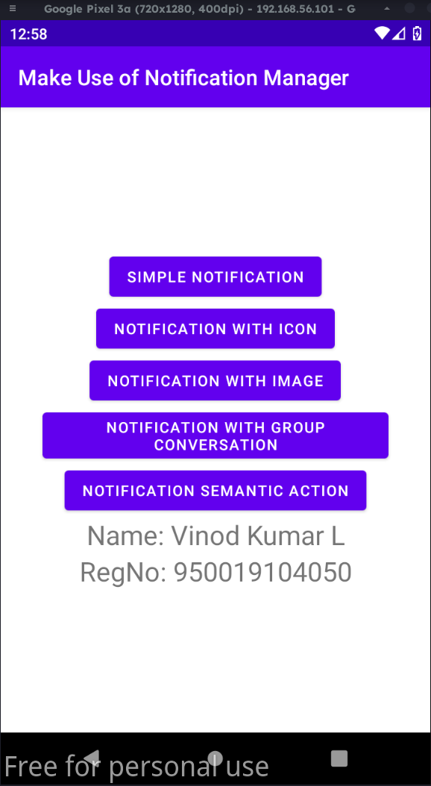

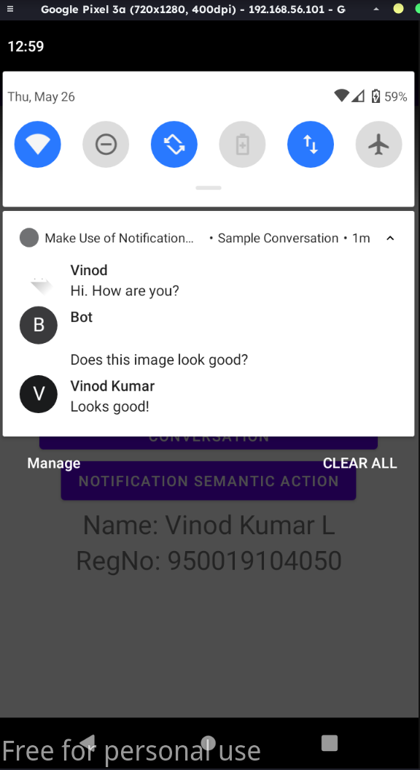
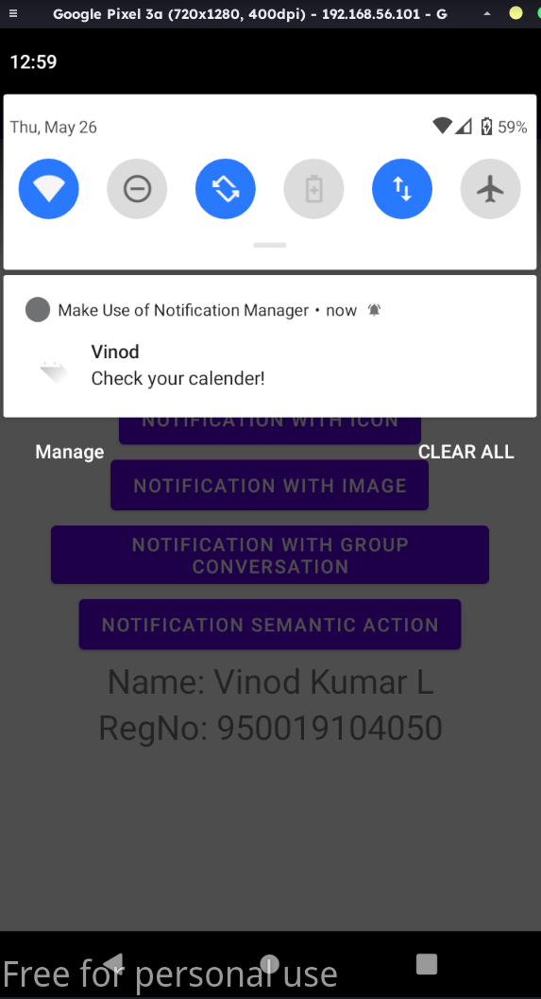

activity_main.xml:

<?xml version="1.0" encoding="utf-8"?>
<LinearLayout xmlns:android="http://schemas.android.com/apk/res/android"
android:layout_width="match_parent"
android:layout_height="match_parent"
android:orientation="vertical" >
<ImageView
android:id="@+id/imageView"
android:layout_width="250dp"
android:layout_height="250dp"
android:layout_margin="50dp"
android:layout_gravity="center" />
<Button
android:id="@+id/button"
android:layout_width="wrap_content"
android:layout_height="wrap_content"
android:layout_margin="10dp"
android:layout_gravity="center"
android:text="Load Image 1" />
<Button
android:id="@+id/button2"
android:layout_width="wrap_content"
android:layout_height="wrap_content"
android:layout_margin="10dp"
android:layout_gravity="center"
android:text="Load image 2" />
<TextView android:id="@+id/textView11"
android:layout_width="match_parent"
android:layout_height="wrap_content"
android:gravity="center"
android:text="Name: Vinod Kumar L"
android:textSize="25sp" />

<TextView
android:id="@+id/textView12"
android:layout_width="match_parent"
android:layout_height="wrap_content"
android:gravity="center"
android:text="RegNo: 950019104050"
android:textSize="25sp" />
</LinearLayout>

MainActivity.java:

package multi.threading;

import android.os.Bundle;
import android.view.View;
import android.widget.Button;
import android.widget.ImageView;
import androidx.appcompat.app.AppCompatActivity;
public class MainActivity extends AppCompatActivity
{
ImageView img;
Button bt1,bt2;
@Override
protected void onCreate(Bundle savedInstanceState)
{
super.onCreate(savedInstanceState);
setContentView(R.layout.activity_main);
bt1 = (Button)findViewById(R.id.button);
bt2= (Button) findViewById(R.id.button2);
img = (ImageView)findViewById(R.id.imageView);
bt1.setOnClickListener(new View.OnClickListener()
{
@Override
public void onClick(View v)
{
new Thread(new Runnable()
{
@Override
public void run()
{
img.post(new Runnable()
{
@Override
public void run()
{
img.setImageResource(R.drawable.archlogo);
}
});
} }).start();
} });

bt2.setOnClickListener(new View.OnClickListener()
{
@Override
public void onClick(View v)
{
new Thread(new Runnable()
{
@Override
public void run()
{
img.post(new Runnable()
{
@Override
public void run()
{
img.setImageResource(R.drawable.archlogo1);
} });
}
}).start();
} });
}}

Output:

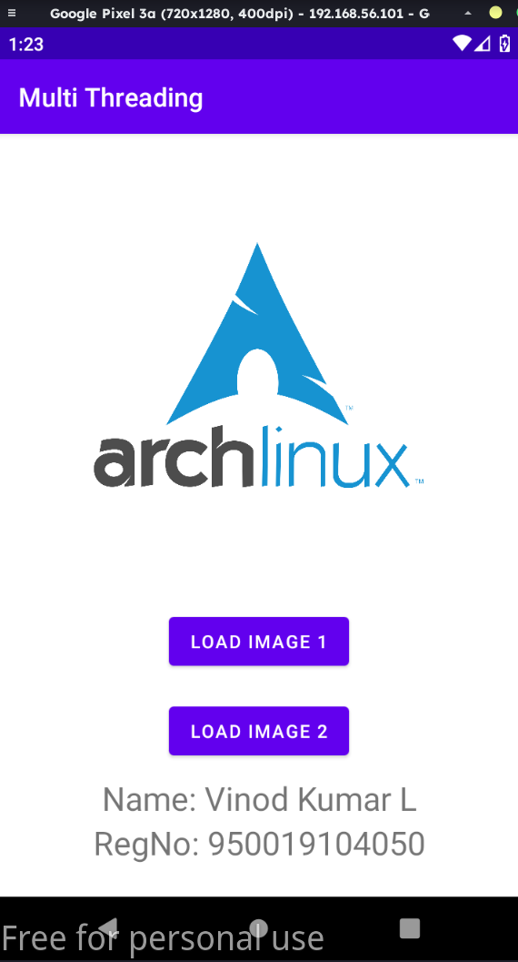
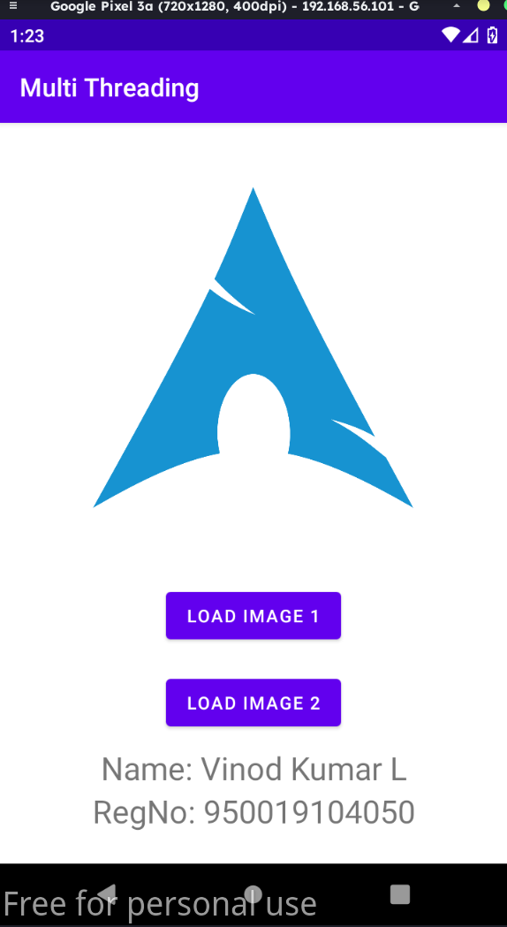

activity_main.xml:
<?xml version = "1.0" encoding = "utf-8"?>
<LinearLayout xmlns:android = "http://schemas.android.com/apk/res/android"
android:layout_width = "match_parent"
android:layout_height = "match_parent"
android:orientation = "vertical"
>
<Button
android:id="@+id/button"
android:layout_width="match_parent"
android:layout_height="wrap_content"
android:layout_marginLeft="24dp"
android:layout_marginTop="340dp"
android:layout_marginRight="24dp"
android:backgroundTint="#03FFFFFF"
android:text="getlocation" />
<TextView android:id="@+id/textView11"
android:layout_width="match_parent"
android:layout_height="wrap_content"
android:gravity="center"
android:text="Name: Vinod Kumar L"
android:textSize="25sp" />
<TextView
android:id="@+id/textView12"
android:layout_width="match_parent"
android:layout_height="wrap_content"
android:gravity="center"
android:text="RegNo: 950019104050"
android:textSize="25sp" />
</LinearLayout>
MainActivity.java
package gps.location.info;

import android.Manifest;
import android.app.Activity;
import android.content.pm.PackageManager;
import android.os.Bundle;
import android.view.View;
import android.widget.Button;
import android.widget.Toast;

import androidx.core.app.ActivityCompat;

import gps.location.info.GPSTracker;

//import android.support.v4.app.ActivityCompat;

public class MainActivity extends Activity {
Button btnShowLocation;
private static final int REQUEST_CODE_PERMISSION = 2;
String mPermission = Manifest.permission.ACCESS_FINE_LOCATION;
// GPSTracker class
GPSTracker gps;
@Override
public void onCreate(Bundle savedInstanceState) {
super.onCreate(savedInstanceState);
setContentView(R.layout.activity_main);
try {
if (ActivityCompat.checkSelfPermission(this, mPermission)
!= PackageManager.PERMISSION_GRANTED) {

ActivityCompat.requestPermissions(this, new String[]{mPermission},
REQUEST_CODE_PERMISSION);
}
} catch (Exception e) {
e.printStackTrace();
}
btnShowLocation = (Button) findViewById(R.id.button);
// show location button click event
btnShowLocation.setOnClickListener(new View.OnClickListener() {
@Override
public void onClick(View arg0) {
// create class object
gps = new GPSTracker(MainActivity.this);
// check if GPS enabled
if(gps.canGetLocation()){
double latitude = gps.getLatitude();
double longitude = gps.getLongitude();
// \n is for new line
Toast.makeText(getApplicationContext(), "Your Location is - \nLat: "
+ latitude + "\nLong: " + longitude, Toast.LENGTH_LONG).show();
}else{
// can't get location
// GPS or Network is not enabled
// Ask user to enable GPS/network in settings
gps.showSettingsAlert();
}
}
});
}
}
GPSTracker.java:
package gps.location.info;

import android.annotation.SuppressLint;
import android.app.AlertDialog;
import android.app.Service;
import android.content.Context;
import android.content.DialogInterface;
import android.content.Intent;
import android.location.Location;
import android.location.LocationListener;
import android.location.LocationManager;
import android.os.Bundle;
import android.os.IBinder;
import android.provider.Settings;
import android.util.Log;

public class GPSTracker extends Service implements LocationListener {
private final Context mContext;
// flag for GPS status
boolean isGPSEnabled = false;
// flag for network status
boolean isNetworkEnabled = false;
// flag for GPS status
boolean canGetLocation = false;
Location location; // location
double latitude; // latitude
double longitude; // longitude
// The minimum distance to change Updates in meters
private static final long MIN_DISTANCE_CHANGE_FOR_UPDATES = 10; // 10 meters
// The minimum time between updates in milliseconds
private static final long MIN_TIME_BW_UPDATES = 1000 * 60 * 1; // 1 minute
// Declaring a Location Manager
protected LocationManager locationManager;
public GPSTracker(Context context) {
this.mContext = context;
getLocation();
}
@SuppressLint("MissingPermission")
public Location getLocation() {
try {
locationManager = (LocationManager) mContext.getSystemService(LOCATION_SERVICE);
// getting GPS status
isGPSEnabled = locationManager.isProviderEnabled(LocationManager.GPS_PROVIDER);
// getting network status
isNetworkEnabled = locationManager
.isProviderEnabled(LocationManager.NETWORK_PROVIDER);
if (!isGPSEnabled && !isNetworkEnabled) {
// no network provider is enabled
} else {
this.canGetLocation = true;
// First get location from Network Provider
if (isNetworkEnabled) {
locationManager.requestLocationUpdates(
LocationManager.NETWORK_PROVIDER,
MIN_TIME_BW_UPDATES,
MIN_DISTANCE_CHANGE_FOR_UPDATES, this);
Log.d("Network", "Network");
if (locationManager != null) {
location = locationManager
.getLastKnownLocation(LocationManager.NETWORK_PROVIDER);
if (location != null) {
latitude = location.getLatitude();
longitude = location.getLongitude();
}
}
}
// if GPS Enabled get lat/long using GPS Services
if (isGPSEnabled) {
if (location == null) {
locationManager.requestLocationUpdates(
LocationManager.GPS_PROVIDER, MIN_TIME_BW_UPDATES,
MIN_DISTANCE_CHANGE_FOR_UPDATES, this);
Log.d("GPS Enabled", "GPS Enabled");
if (locationManager != null) {
location = locationManager.getLastKnownLocation(LocationManager.GPS_PROVIDER);
if (location != null) {
latitude = location.getLatitude();
longitude = location.getLongitude();
}
}
}
}
}
} catch (Exception e) {
e.printStackTrace();
}
return location;
}
/**
* Stop using GPS listener
* Calling this function will stop using GPS in your app
* */
public void stopUsingGPS(){
if(locationManager != null){
locationManager.removeUpdates(GPSTracker.this);
}
}
/**
* Function to get latitude
* */
public double getLatitude(){
if(location != null){
latitude = location.getLatitude();
}
// return latitude
return latitude;
}
/**
* Function to get longitude
* */
public double getLongitude(){
if(location != null){
longitude = location.getLongitude();
}
// return longitude
return longitude;
}
/**
* Function to check GPS/wifi enabled
* @return boolean
* */
public boolean canGetLocation() {
return this.canGetLocation;
}
/**
* Function to show settings alert dialog
* On pressing Settings button will lauch Settings Options
* */
public void showSettingsAlert(){
AlertDialog.Builder alertDialog = new AlertDialog.Builder(mContext);
// Setting Dialog Title
alertDialog.setTitle("GPS is settings");
// Setting Dialog Message
alertDialog.setMessage("GPS is not enabled. Do you want to go to settings menu?");
// On pressing Settings button
alertDialog.setPositiveButton("Settings", new DialogInterface.OnClickListener() {
public void onClick(DialogInterface dialog,int which) {
Intent intent = new Intent(Settings.ACTION_LOCATION_SOURCE_SETTINGS);
mContext.startActivity(intent);
}
});
// on pressing cancel button
alertDialog.setNegativeButton("Cancel", new DialogInterface.OnClickListener() {
public void onClick(DialogInterface dialog, int which) {
dialog.cancel();
}
});
// Showing Alert Message
alertDialog.show();
}
@Override
public void onLocationChanged(Location location) {
}
@Override
public void onProviderDisabled(String provider) {
}
@Override
public void onProviderEnabled(String provider) {
}
@Override
public void onStatusChanged(String provider, int status, Bundle extras) {
}
@Override
public IBinder onBind(Intent arg0) {
return null;
}
}

AndroidManifest.xml:
<uses-permission android:name="android.permission.ACCESS_COARSE_LOCATION" />
<uses-permission android:name="android.permission.ACCESS_FINE_LOCATION" />
<uses-permission android:name = "android.permission.INTERNET" />

Output:
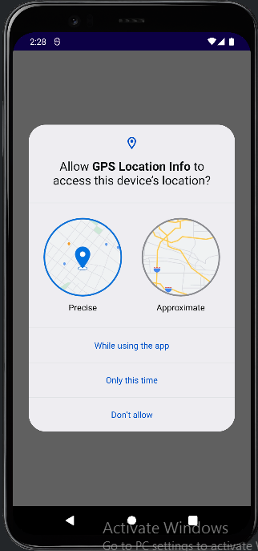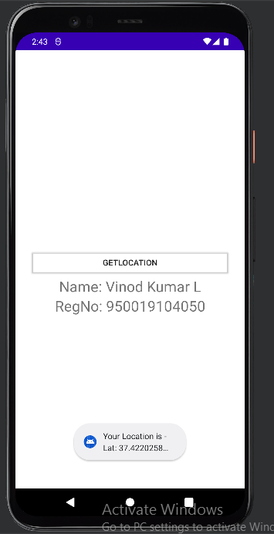

activity_main.xml
<?xml version="1.0" encoding="utf-8"?>
<LinearLayout xmlns:android="http://schemas.android.com/apk/res/android"
android:layout_width="match_parent"
android:layout_height="match_parent"
android:layout_margin="20dp"
android:orientation="vertical">

<EditText
android:id="@+id/editText"
android:layout_width="match_parent"
android:layout_height="wrap_content"
android:singleLine="true"
android:textSize="30dp" />

<Button
android:id="@+id/button"
android:layout_width="match_parent"
android:layout_height="wrap_content"
android:layout_margin="10dp"
android:text="Write Data"
android:textSize="30dp" />

<Button
android:id="@+id/button2"
android:layout_width="match_parent"
android:layout_height="wrap_content"
android:layout_margin="10dp"
android:text="Read data"
android:textSize="30dp" />

<Button
android:id="@+id/button3"
android:layout_width="match_parent"
android:layout_height="wrap_content"
android:layout_margin="10dp"
android:text="Clear"
android:textSize="30dp" />
<TextView android:id="@+id/textView11"
android:layout_width="match_parent"
android:layout_height="wrap_content"
android:gravity="center"
android:text="Name: Vinod Kumar L"
android:textSize="25sp" />

<TextView
android:id="@+id/textView12"
android:layout_width="match_parent"
android:layout_height="wrap_content"
android:gravity="center"
android:text="RegNo: 950019104050"
android:textSize="25sp" />

</LinearLayout>

AndroidManifest.xml
<uses-permission android:name="android.permission.WRITE_EXTERNAL_STORAGE"></uses-permission>

MainActivity.java:
package write.data.tosdcard;

import android.os.Bundle;
import androidx.appcompat.app.AppCompatActivity;
import android.view.View;
import android.widget.Button;
import android.widget.EditText;
import android.widget.Toast;

import java.io.BufferedReader;
import java.io.File;
import java.io.FileInputStream;
import java.io.FileOutputStream;
import java.io.InputStreamReader;

public class MainActivity extends AppCompatActivity
{
EditText e1;
Button write,read,clear;
@Override
protected void onCreate(Bundle savedInstanceState)
{
super.onCreate(savedInstanceState);
setContentView(R.layout.activity_main);

e1= (EditText) findViewById(R.id.editText);
write= (Button) findViewById(R.id.button);
read= (Button) findViewById(R.id.button2);
clear= (Button) findViewById(R.id.button3);

write.setOnClickListener(new View.OnClickListener()
{
@Override
public void onClick(View v)
{
String message=e1.getText().toString();
try
{
File f=new File("/sdcard/myfile.txt");
f.createNewFile();
FileOutputStream fout=new FileOutputStream(f);
fout.write(message.getBytes());
fout.close();
Toast.makeText(getBaseContext(),"Data Written in SDCARD",Toast.LENGTH_LONG).show();
}
catch (Exception e)
{
Toast.makeText(getBaseContext(),e.getMessage(),Toast.LENGTH_LONG).show();
}
}
});

read.setOnClickListener(new View.OnClickListener()
{
@Override
public void onClick(View v)
{
String message;
String buf = "";
try
{
File f = new File("/sdcard/myfile.txt");
FileInputStream fin = new FileInputStream(f);
BufferedReader br = new BufferedReader(new InputStreamReader(fin));
while ((message = br.readLine()) != null)
{
buf += message;
}
e1.setText(buf);
br.close();
fin.close();
Toast.makeText(getBaseContext(),"Data Recived from SDCARD",Toast.LENGTH_LONG).show();
}
catch (Exception e)
{
Toast.makeText(getBaseContext(), e.getMessage(), Toast.LENGTH_LONG).show();
}
}
});

clear.setOnClickListener(new View.OnClickListener()
{
@Override
public void onClick(View v)
{
e1.setText("");
}
});
}
}

